Support Vector Machine (SVM)
Mathematical intuition:- https://www.analyticsvidhya.com/blog/2021/10/support-vector-machinessvm-a-complete-guide-for-beginners/
For MMC – Support Vector, Hyperplane, and Margin (Romance Song!)
1. The data/vector points closest to the hyperplane (black line) are known as the support vector (SV) data points because only these two points are contributing to the result of the algorithm (SVM), other points are not.
2. If a data point is not an SV, removing it has no effect on the model.
3. Deleting the SV will then change the position of the hyperplane.
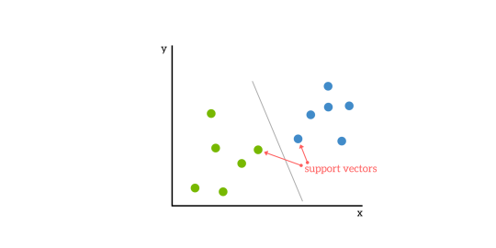Image Source: google.image.com
The dimension of the hyperplane depends upon the number of features. If the number of input features is 2, then the hyperplane is just a line. If the number of input features is 3, then the hyperplane becomes a two-dimensional plane. It becomes difficult to imagine when the number of features exceeds 3.
Support Vector Classifier (SVC)(Second Song):
Many have confusion with the terms SVM and SVC, the simple answer is if the hyperplane that we are using for classification is in linear condition, then the condition is SVC.
The distance of the vectors from the hyperplane is called the margin which is a separation of a line to the closest class points. We would like to choose a hyperplane that maximizes the margin between classes. The graph below shows what good margins and bad margins are.
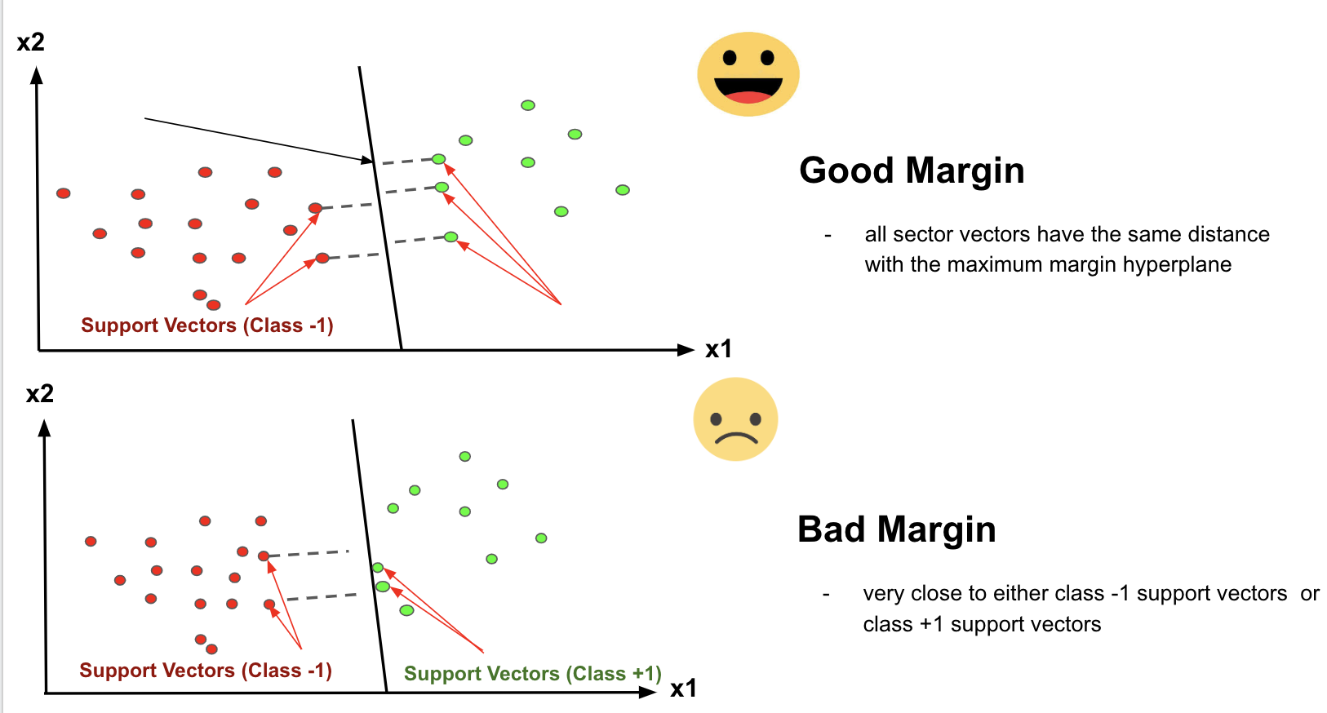Image Source: image.google.com
Again Margin can be sub-divided into,
1. Soft Margin – As most of the real-world data are not fully linearly separable, we will allow some margin violation to occur which is called soft margin classification. It is better to have a large margin, even though some constraints are violated. Margin violation means choosing a hyperplane, which can allow some data points to stay on either the incorrect side of the hyperplane and between the margin and correct side of the hyperplane.
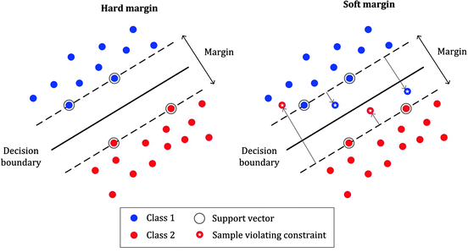Image Source: medium.com
2. Hard Margin – If the training data is linearly separable, we can select two parallel hyperplanes that separate the two classes of data, so that the distance between them is as large as possible.
Note: In order to find the maximal margin, we need to maximize the margin between the data points and the hyperplane.
Slight Mathematics (Confused scene):

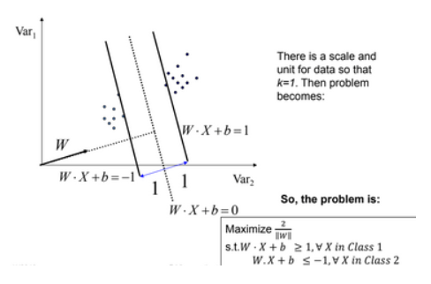Image Source: https://iq.opengenus.org/
The whole mathematics related with SVM is summarized in both the picture in short, above and below picture,

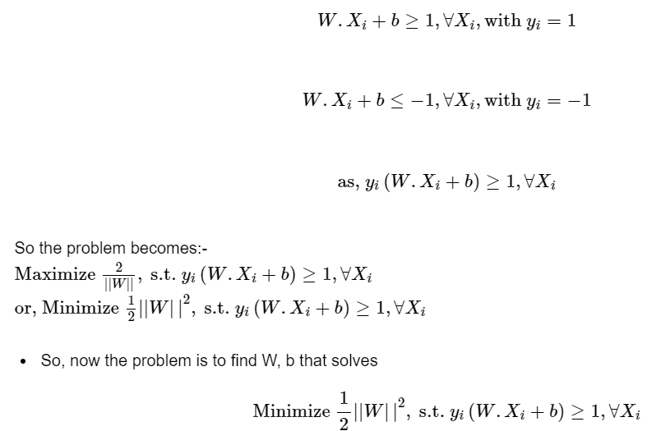Image Source: https://iq.opengenus.org/
Limitation of SVC (Sudden Twist in the movie):
There are some limitations with SVC, that can be explained by the below picture,
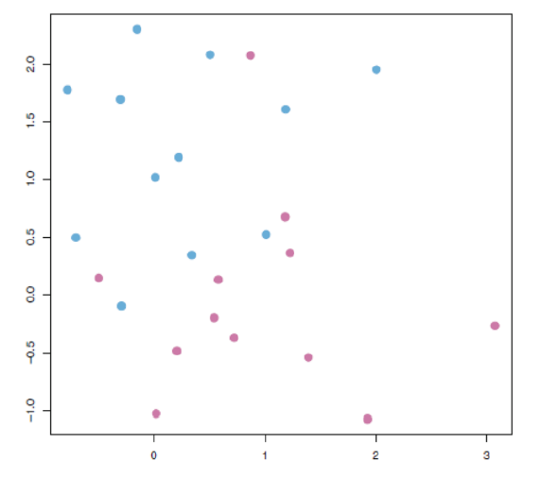Image Source: image.google.com
Here in the above picture if you noticed clearly, we cannot draw a hyperplane in this scattered data to separate the data points between classes (for classification!) by a straight line or technically we call it linearly.
Support Vector Machine (SVM) – (Interval block):
The limitation of SVC is compensated by SVM non-linearly. And that’s the difference between SVM and SVC. If the hyperplane classifies the dataset linearly then the algorithm we call it as SVC and the algorithm that separates the dataset by non-linear approach then we call it as SVM.
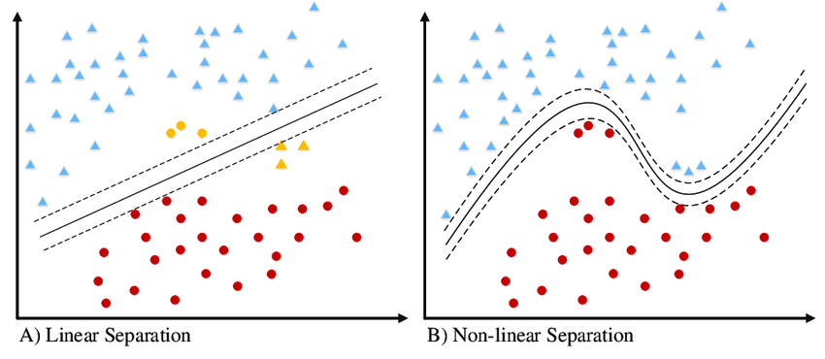Image Source: image.google.com
SVM has a technique called the kernel trick. These are functions that take low dimensional input space and transform it into a higher-dimensional space i.e. it converts not separable problem to separable problem.

Support Vector Machines (SVMs) are a type of supervised machine learning algorithm used for classification and regression tasks. They are widely used in various fields, including pattern recognition, image analysis, and natural language processing.
Press enter or click to view image in full size
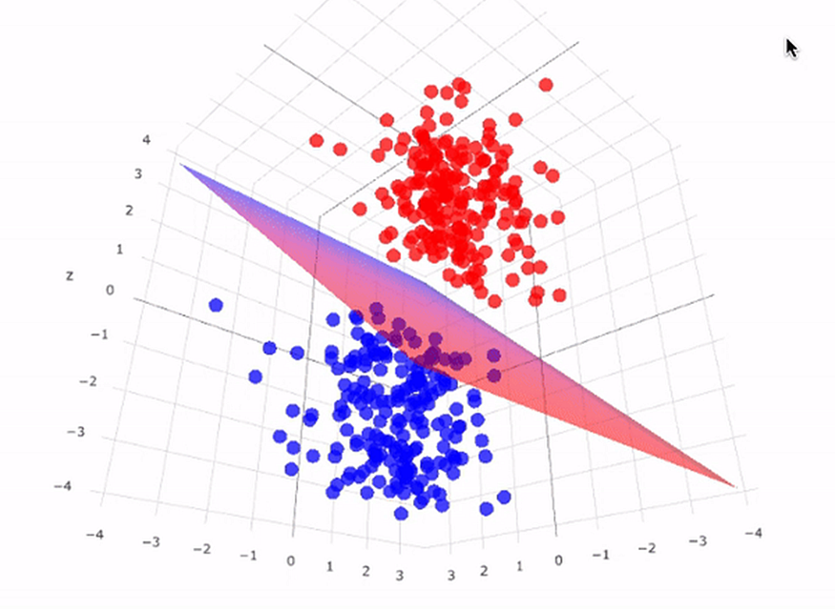
SVMs work by finding the optimal hyperplane that separates data points into different classes.
Key Terms
Hyperplane
A hyperplane is a decision boundary that separates data points into different classes in a high-dimensional space. In two-dimensional space, a hyperplane is simply a line that separates the data points into two classes. In three-dimensional space, a hyperplane is a plane that separates the data points into two classes. Similarly, in N-dimensional space, a hyperplane has (N-1)-dimensions.
It can be used to make predictions on new data points by evaluating which side of the hyperplane they fall on. Data points on one side of the hyperplane are classified as belonging to one class, while data points on the other side of the hyperplane are classified as belonging to another class.
Press enter or click to view image in full size
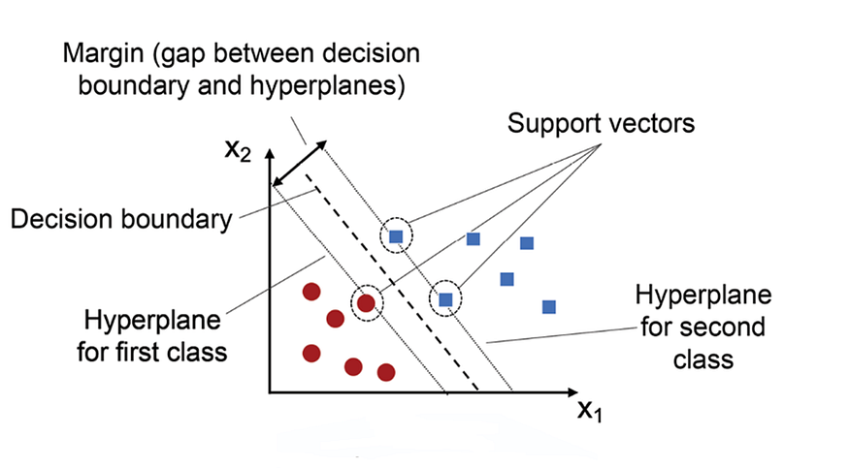
Margin
A margin is the distance between the decision boundary (hyperplane) and the closest data points from each class. The goal of SVMs is to maximize this margin while minimizing classification errors. A larger margin indicates a greater degree of confidence in the classification, as it means that there is a larger gap between the decision boundary and the closest data points from each class. The margin is a measure of how well-separated the classes are in feature space. SVMs are designed to find the hyperplane that maximizes this margin, which is why they are sometimes referred to as maximum-margin classifiers.
Press enter or click to view image in full size
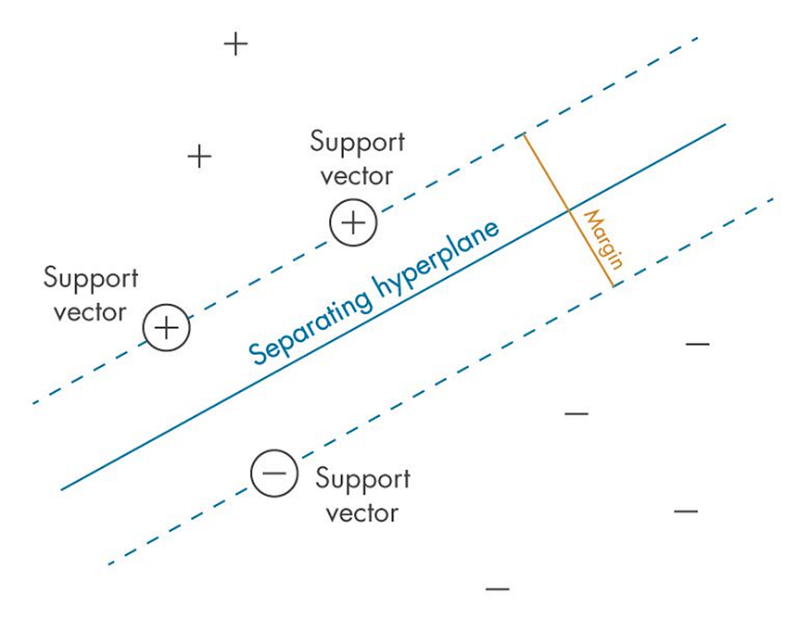
Support Vectors
They are the data points that lie closest to the decision boundary (hyperplane) in a Support Vector Machine (SVM). These data points are important because they determine the position and orientation of the hyperplane, and thus have a significant impact on the classification accuracy of the SVM. In fact, SVMs are named after these support vectors because they “support” or define the decision boundary. The support vectors are used to calculate the margin, which is the distance between the hyperplane and the closest data points from each class. The goal of SVMs is to maximize this margin while minimizing classification errors.
Understanding SVM with an example dataset
Press enter or click to view image in full size
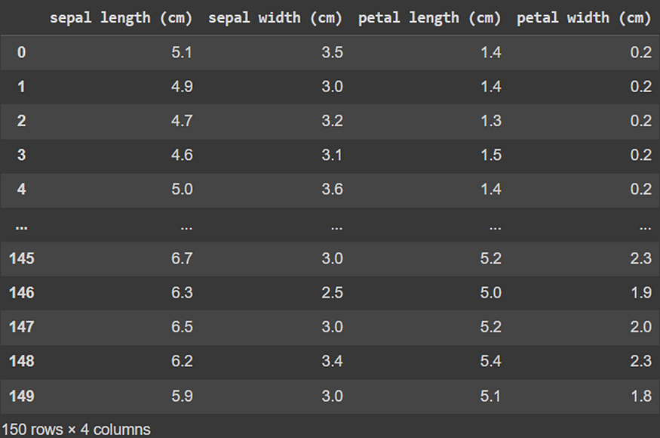
Iris Dataset from the Scikit-learn library in Python.
We have a famous dataset called ‘Iris’. There are four features (columns or independent variables) in this dataset but for simplicity purposes, we shall on look at two which are: ‘Petal length’ and ‘Petal Width’. These points are then plotted on a 2D plane.
Press enter or click to view image in full size
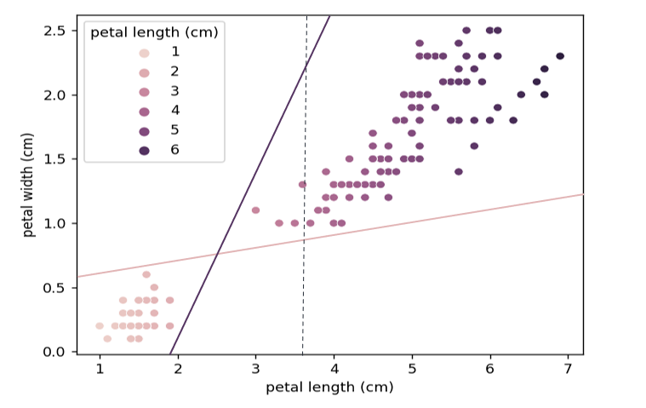
Iris dataset separated by three lines (linear classifiers) represent by dark, light and dotted lines.
Lighter points represent the species ‘Iris Setosa’ and darker ones represent ‘Iris versicolor’.
We can simply classify this by plotting lines, using linear classifiers.
The dark and light lines accurately classify the test data set but may fail on new data due to the closeness of the boundary from the respective classes. Whereas, the dotted line classifier is entirely trash and misclassified many points.
What we want is the best classifier. A classifier which stays farthest from the overall class, that is where SVM comes in.
Press enter or click to view image in full size
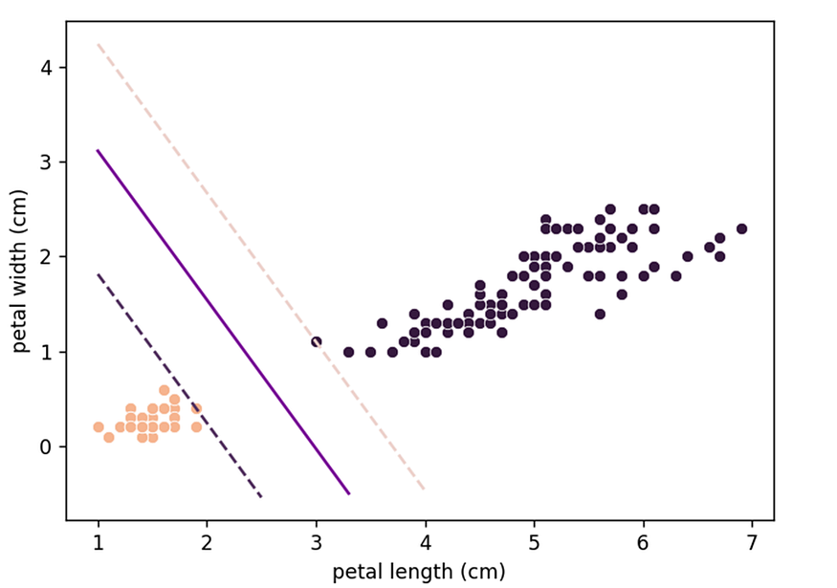
Iris dataset separated by a hyperplane obtained by an SVM model.
We can think of SVM as fitting the widest possible path (represented by parallel dashed lines) between the classes.
This is termed “Large Margin Classification”.
Note. In theory, the hyperplane is exactly between the support vectors. But here it is slightly closer to the dark class. Why? This will be discussed later in the regularization part.
Understanding by an Analogy (You can skip if you understood :)
You can think of SVM as a construction company. The 2D plane is a map and the 2 classes are 2 cities. The data points are analogous to buildings. You are the government and your goal is to create the best highway to minimise traffic which passes through both the cities, but you are constrained by the area available to you.
We are considering the road to be “straight” for now. (We will explore non-linear models later in the article)
You give the contract to SVM construction company. What SVM does to minimise traffic is it wants to maximise the width of the road. It looks at the widest stretch of land between the 2 cities. The buildings at the end of the road are called “Support Vectors” since they are constraining or “Supporting” the model. The highway is angled such that there is equal space for the cities to expand along it.
This central line dividing the highway represents the Decision Boundary (Hyperplane) and the edges represent Hyperplanes for the respective Classes. The width of this highway is the Margin.
What Happens if the data is not linearly classifiable?
When a linear hyperplane is not possible, the input data is transformed into a higher-dimensional feature space, where it may be easier to find a linear decision boundary that separates the classes.
What do I mean by that 😕 ?
Let’s look at an example:
Press enter or click to view image in full size
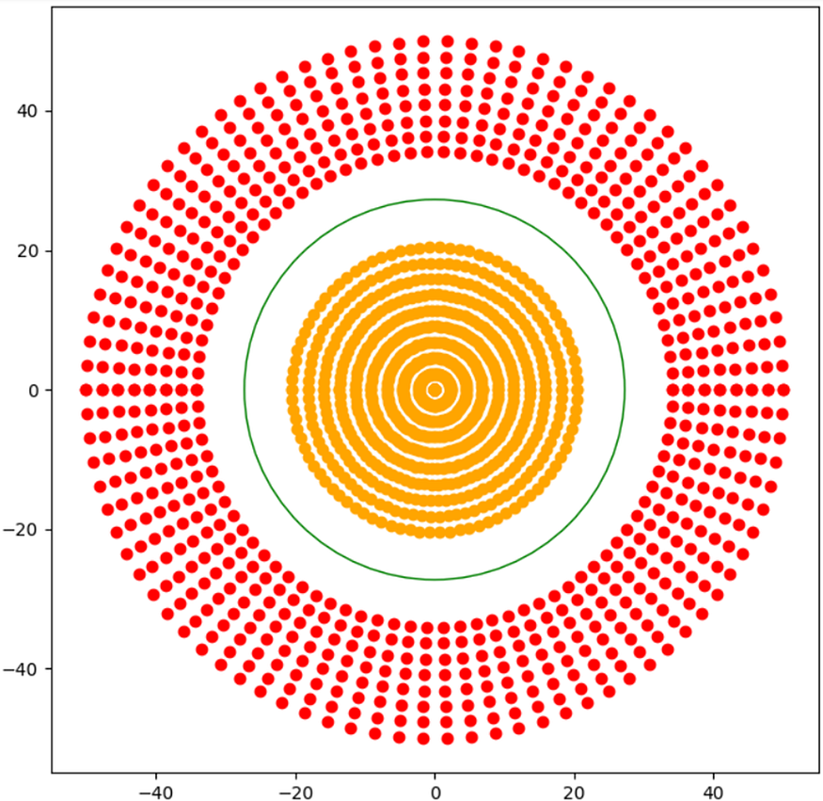
A dataset which is not linearly separable.
In the above figure, a 2-D hyperplane was not possible and hence transformation was required (remember I told you the case if the highway wasn’t straight).
What is transformation or addition of a new feature?
We have two features X and Y, and the data which not linearly classifiable. What we need to do is add another dimension in which if the data is plotted it becomes linearly separable.
Values of a point in the dimensions are nothing but column values of the point. To add another dimension we have to create another column (or feature).
Here we have two features X and Y, a third feature is needed which will be a function of the original features i.e. X and Y, which will be enough to classify the data linearly in three dimensions.
We take the third feature Z = f(x,y); f representing a function on X and Y. Here the Radial Basis Function(RBF) (measuring Euclidean distance) from the origin is enough.
Z = (X²+ Y²)^(1/2)
Press enter or click to view image in full size
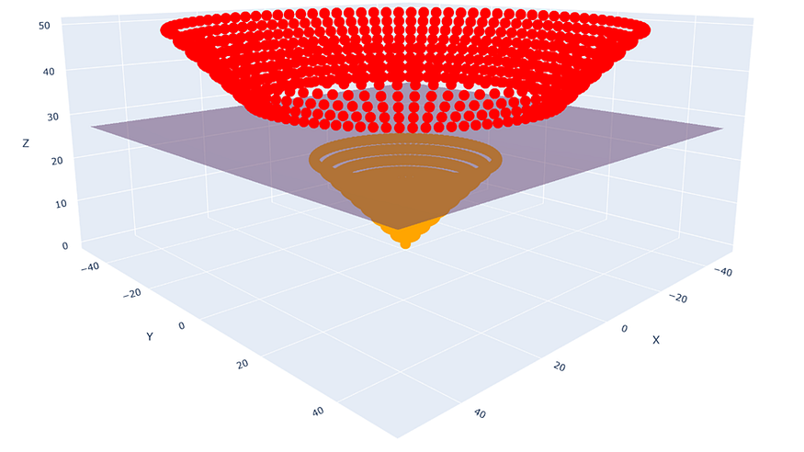
The points, plotted in 3-D with a hyperplane dividing them
Here the hyperplane was as simple as creating a plane parallel to the X-Y plane at a certain height.
Problems with this method
The main problem here is the heavy load of the calculations to be performed.
Here we took points centred on origin in a concentric manner. Suppose the points were not concentric but could be separated by the RBF. So we would need to take each point in the dataset as a reference each time and find the distance of all other points with respect to that point.
So we would need to calculate n*(n-1)/2 distances. (n-1 other points with respect to each n points, but once the distance of 1–2 is calculated the distance of 2–1 does need to be calculated)
Time Complexity
The time complexity of a square root is O(log(n)) and for power, addition is O(1). Thus to do n*(n-1)/2 total calculations we would need O(n²log(n)) time complexity.
But as our goal is to separate the classes and not find the distance, we can do away with the square root. (Z = X²+ Y²)
In that case, we would get a time complexity of O(n²).
But this was not even the problem, the problem starts now
Here we knew which function was to be used. But there could be many functions with just the degree limited to 2 (X, Y, XY, X² and Y²).
We can use these 5 as 3 dimensions in ⁵C₃ ways = 10 ways. Not to mention, the infinite possibility of their linear combinations (Z = 4X² + 7XY + 13Y², Z= 8XY +17X², and so on…).
And this was only for 2-degree polynomials. If we started using 3-degree polynomials then X³, Y³, X²Y, XY² will also come in the picture.
Not all of these are good enough to be our additional feature.
For example, I started with (X vs Y vs XY as the features):
Press enter or click to view image in full size
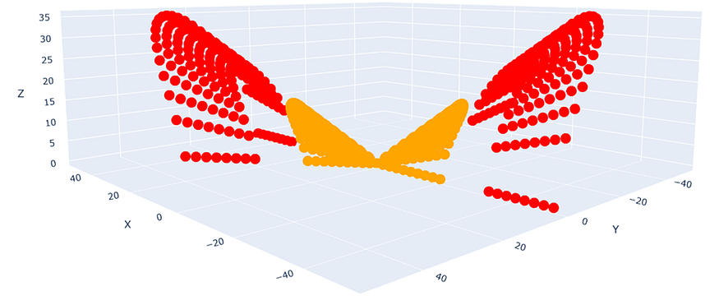
X vs Y vs XY plot of the same data, this plot is not linearly classifiable [Doesn’t the figure look like two birds that have touched their beaks].
All the calculations and computations that went into this plot were in vain.
Now we have to use another function as the feature and try again.
Say, I use (X²+vs Y² vs XY as the features, yes I replaced X and Y):
Press enter or click to view image in full size
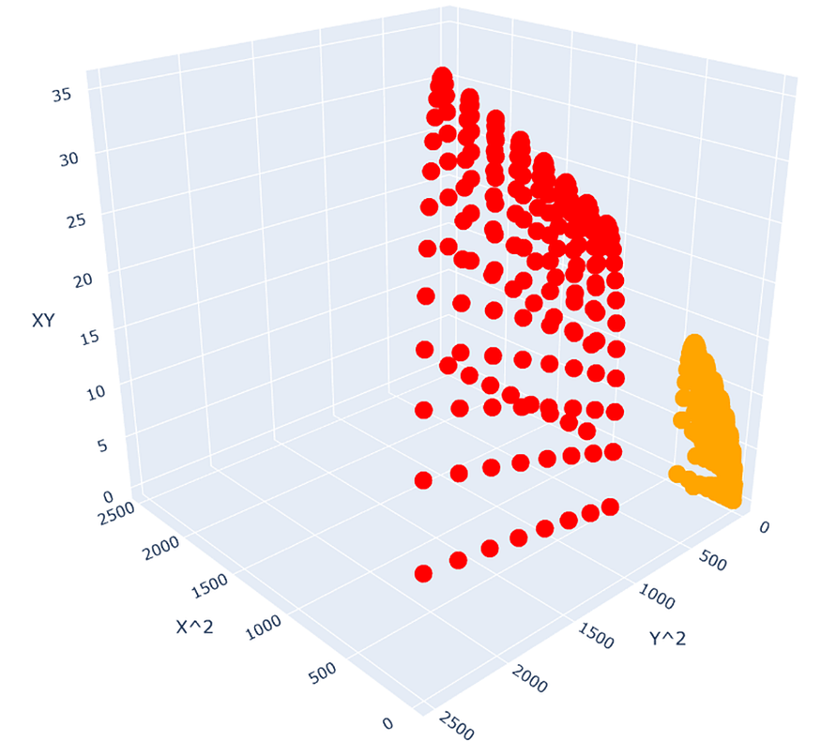
X² vs Y² vs XY plot of the same data, this plot is linearly classifiable [Doesn’t the figure look like a bird with its beak].
I saw that earlier data and noticed that it wasn't linearly separable since yellow was in between the red points.
Since the two yellow beaks met at the centre and one of them was going in the negative X and negative Y direction, I decided to square X and Y so that a new set of values begin from 0 forming only a single separation region between the beak and the bird’s face as compared to two earlier.
This plot is linearly separable, in this way, we can reuse the XY calculations and plot smartly to get the desired features to separate the data.
But even this has limitations, such as using only one or two feature datasets so we get a plot in 3-d and not more dimensions, also our brain's capacity to look for patterns to identify the next set of features and what if the first plot had no pattern so we had to again take a guess for a feature and start from scratch.
If we got the desired feature set in only two steps as we got above, even then this method is slower than the one we actually use.
What we use is called the Kernel Trick.
The Kernel Trick
A Kernel Trick instead of adding another dimension/feature, finds the similarity of the points.
Instead of finding f(x,y) directly, it computes the similarity of the image of these points. In other words, instead of finding f(x1,y1) and f(x2,y2) we take the points (x1,y1) and (x2,y2) and compute how similar would their outputs be using a function f(x,y); where f can be any function on x,y.
Thus we don’t need to find a suitable set of features here. We find similarity in such a way that it is valid for all sets of features.
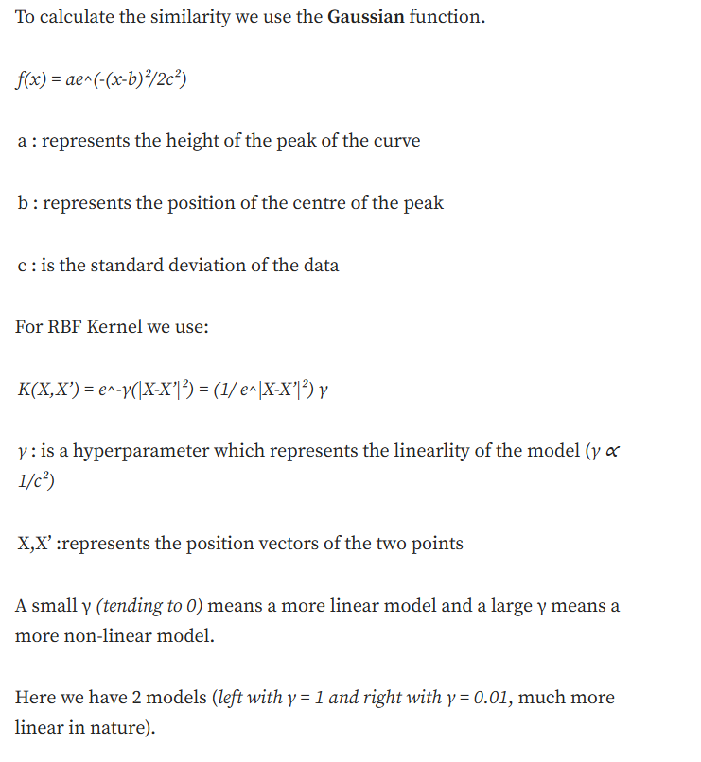
Press enter or click to view image in full size
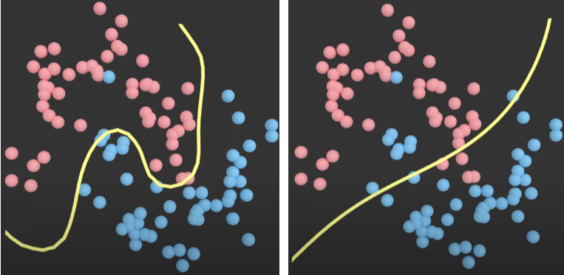
Two Models with Different Gamma Values.
So why not let gamma be a very high value? What is the use of a low γ?
Large values of gamma may lead to overfitting as well and thus we need to find appropriate gamma values.
Figure with 3 models, from left γ = 0.1, γ = 10, γ = 100. (The left one is accurately fitted, the middle is overfitted and the right one is extremely overfitted)
Press enter or click to view image in full size
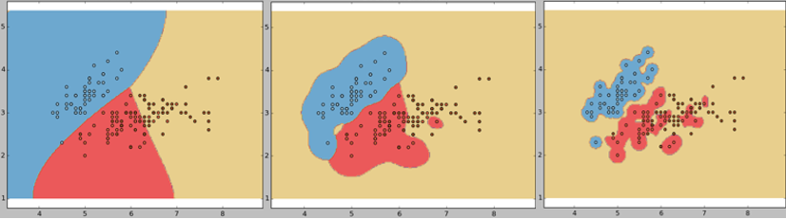
Three Models with Different Gamma Values.
Time Complexity
Since we need to find the similarity of each point with respect to all other points we need a total of n*(n-1)/2 calculations.
Exponent has a time complexity of O(1) and thus we get a total time complexity of O(n²).
We do not need to plot points, check feature sets, take combinations, etc. This makes this method way more efficient.
What we do have here is the usage of different Kernels for this.
We have Kernels such as:
Polynomial Kernel
Gaussian Kernel
Gaussian RBF Kernel
Laplace RBF Kernel
Hyperbolic Tangent Kernel
Sigmoid Kernel
Bessel function of first kind Kernel
ANOVA radial basis Kernel
Linear Splines Kernel

Whichever one we use, we get results in lesser computations than the original method.
To further optimise our calculations we use the “Gram Matrix”.
The Gram Matrix is a matrix which can be easily stored and manipulated in the memory and is highly efficient to use.

Kernel:
In this parameter, it’s very simple, in this parameter few option’s are there like if you want to model it in a linear manner, we go for ‘linear’ or if your model did not have proper accuracy then you go for non-linear SVM like ‘rbf’, ‘poly’ and ‘sigmoid’ for better accuracy. Let’s assume as like below,
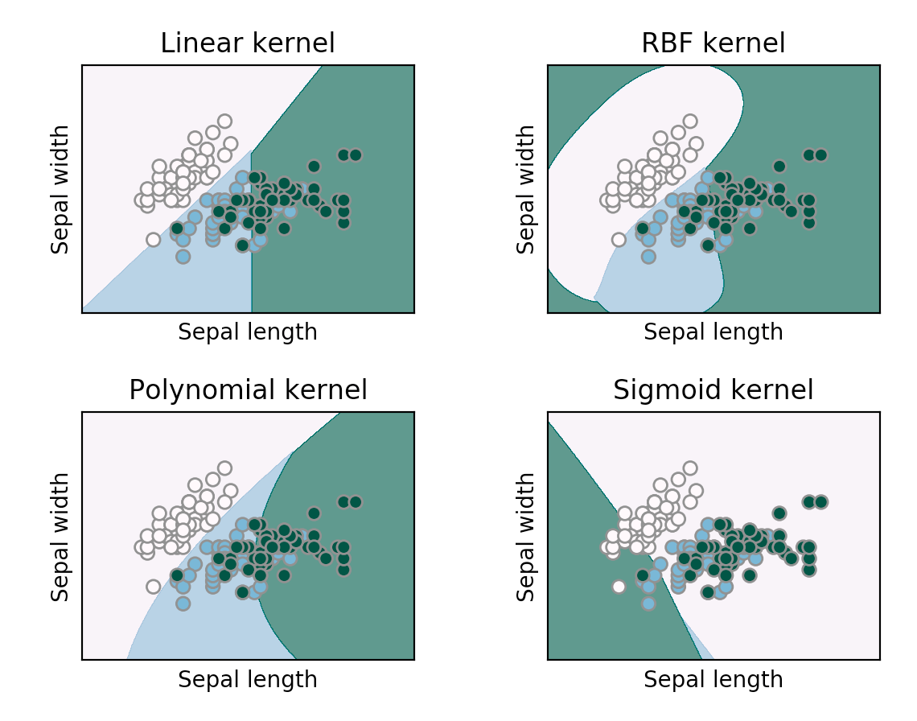Image Source: image.google.com
Degree:
1. It controls the flexibility of the decision boundary.
2. Higher degrees yield more flexible decision boundaries.
3. Highly recommended for polynomial kernel
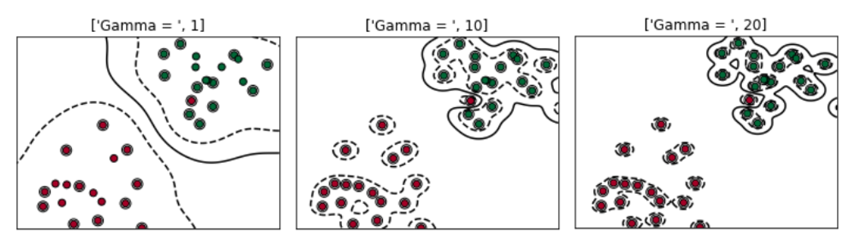Image Source: towardsdatascience.com
Random State:
This particular parameter, 50-50 people use it and others won’t. This is not so important, ensures that the splits that you generate are reproducible, like we give mostly the value as 0 or 1 or it may be any other number too.

Regularization and Soft Margin SVM
Finally, Onto a new topic 😮‍💨(phew).
If we strictly impose that all points must be off the street on the correct side then this is called Hard Margin Classification (remember the first SVM model figure that I showed).
There are two issues with this method. First, it would only work with linearly separable data and not for non-linearly separable data (which may be linearly classifiable for the most part).
Second, is its sensitivity to outliers. In the figure below the Red Point is introduced as an outlier in the left class and it significantly changes the decision boundary, this may result in misclassifications of non-outlier data of the second class while testing the model.
Press enter or click to view image in full size
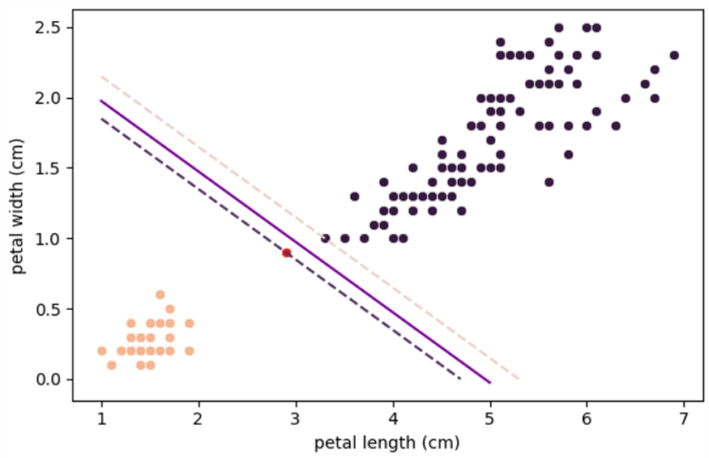
The “Iris” dataset with an outlier completely changes the decision hyperplane.
Although this model has not misclassified any of the points it is not a very good model and will give higher errors during testing.
To avoid this, we use Soft Margin Classification.
A soft margin is a type of margin that allows for some misclassification errors in the training data.
Press enter or click to view image in full size
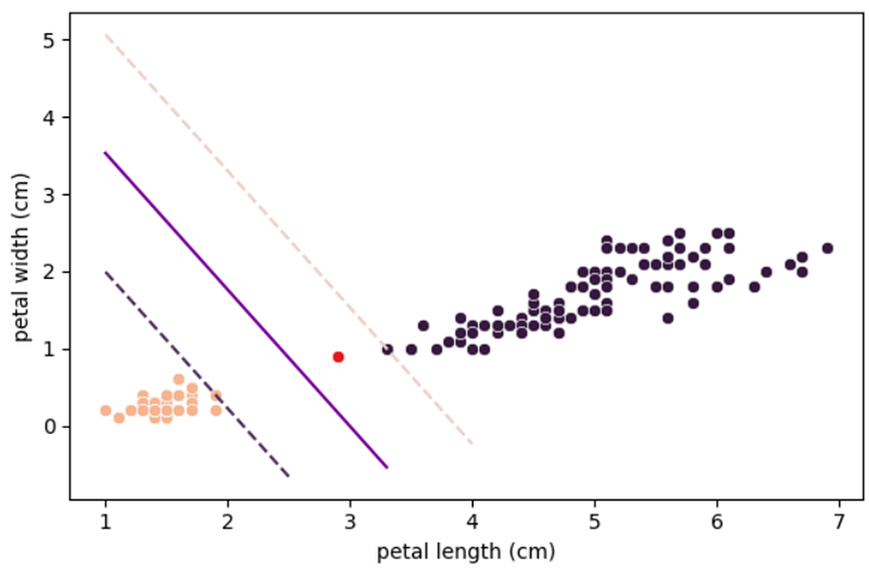
“Iris” dataset with the outlier but with Soft Margin Classification.
Here, a soft margin allows for some misclassification errors by allowing some data points to be on the wrong side of the decision boundary.
Even though there is a misclassification in the training data set and worse performance with respect to the previous model, the general performance would be much better during testing, as a result of how far it is from both classes.
But we can solve the problem of outliers by removing them using data preprocessing and data cleaning right? Then why Soft Margins?
They are used mainly when the data is not linearly separable, meaning that it is not possible to find a hyperplane that perfectly separates the classes without any errors and to avoid outliers (Hard Margin Classification is not possible). Example :
Press enter or click to view image in full size
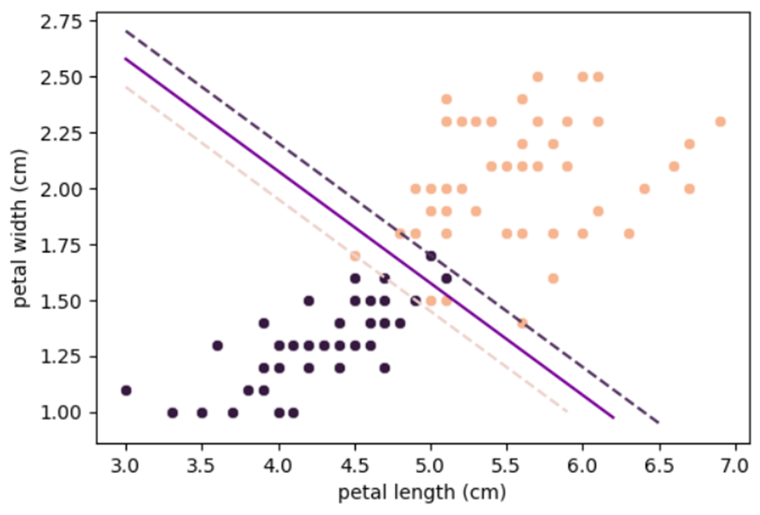
“Iris” dataset (Right Class is Iris Virginica, Left Class is Iris Versicolor), is non-linearly separable but when Soft Margin Classification is used, we get a model with minimum misclassification. (0 minor misclassifications with respect to hyperplanes of respective classes) [5 major misclassifications, wrong side of decision boundary] (Value of C = 100).
How are Soft Margins working?
Soft margins are implemented by introducing a slack variable for each data point, which allows the SVM to tolerate some degree of misclassification error. The amount of tolerance is controlled by a parameter called the regularization hyperparameter C, which determines how much weight should be given to minimizing classification errors versus maximizing the margin.
It controls how much tolerance is allowed for misclassification errors, with larger values of C leading to a harder margin (less tolerance for errors) and smaller values of C leading to a softer margin (more tolerance for errors).
Basically through our analogy, instead of creating a very small road (for the outlier case) when it was not possible to create a large road through the middle of the two cities we create a larger road by moving out some people.
It may be bad for the people moving out (the outlier getting misclassified) but overall the highway (our model) would be way larger (more accurate) and better.
In the case above where no road could be created, we ask some people to move out and create a narrow road. A wider road though better for transport would cause problems for a large number of people (many points getting misclassified).
The regularization hyperparameter ‘C’ controls how many people can be moved out (how many points can be misclassified or tolerance) for the construction of the project.
A high value of C means the model is harder in nature (less tolerant to misclassifications). Whereas a low value of C means that the model is softer in nature (more tolerant to misclassifications).
Press enter or click to view image in full size
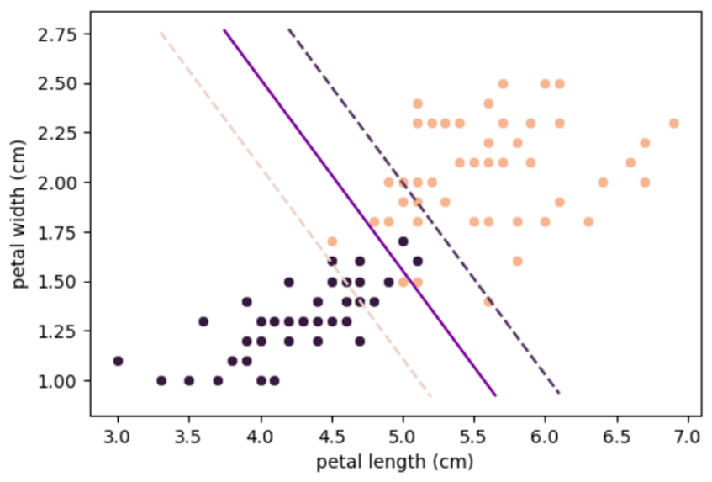
Same Model with the value of C = 1 (12 minor misclassifications with respect to hyperplane of the classes) [4 major misclassifications, wrong side of decision boundary].
A lower C value for the previous model (1 with respect to 100) tolerates more misclassifications, allowing more people to move out and thus building a wider street).
Note. Lower value of C does not necessarily mean more major misclassifications always, sometimes it may mean way more minor classifications.
In this case and for most general cases, low values of C tend to give trash models misclassifying multiple points and reducing accuracy.
Note. A low C is not simply just widening the original path until the required tolerance level is met. It means creating a new widest path by misclassifying the maximum number of points such that it is below the tolerance threshold.
C controls the Bias/Variance trade-off. A low bias means that the model has low or no assumptions about the data. A high variance means that the model will change depending on what we take as training data.
For Hard Margin Classification, the model changes significantly on changing data (if new points were introduced between the hyperplanes) so it has high variance, but it has no assumption about the data there is low bias.
Soft Margin Classification models have negligible changes (due to tolerance to misclassify data) thus they have a low variance. But it assumes we can misclassify some information and assumed that the particular model with a wider margin would lead to better results and thus have a high bias.
Why use low value of C then? Why an appropriate value needs to be chosen
This is a phenomenon similar to overfitting and underfitting which happens with very high values of C and very low values of C.
Very low values will give very poor results as seen (similar to the case of underfitting).
Press enter or click to view image in full size
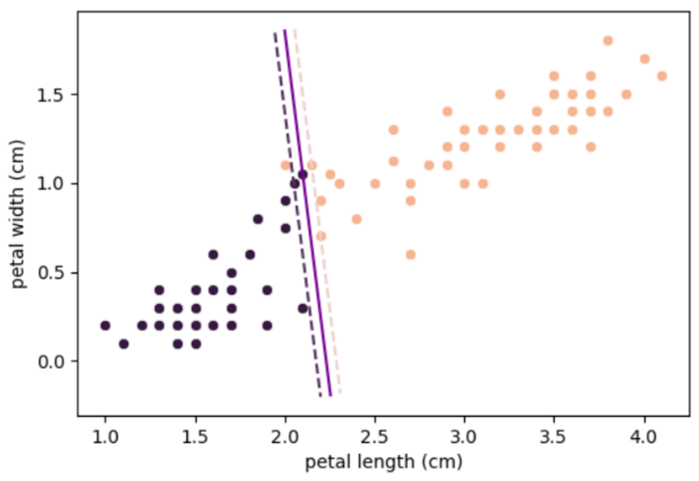
Modified dataset to show the phenomenon.
Model with C = 1000, is unsuitable as it is too close to the left class at the bottom and too close to the right class at the top, with chances of misclassifying data (here there is only 1 major misclassification and 1 minor misclassification hence, during training the model is good, but the model is not good for general decision making and may perform poorly during testing).
Thus models with a very high value of C may also give poor results on testing (similar to the case of overfitting).
Press enter or click to view image in full size
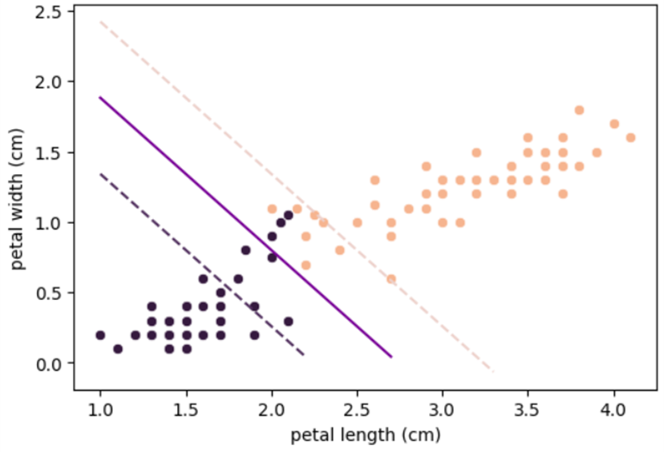
Modified “Iris” dataset used, but here with C = 1.
Model with C = 1, suitable and better-generalised model. (Though there are 3 major misclassifications and about 12 minor misclassifications and thus a worse performance on training data but the model keeps in mind the bulk of the data and creates decision boundaries according to that, hence it has better performance during testing owing to its distance from both the classes).
Note: Minor misclassification is a term which I use to describe data not correctly classified by the class’ hyperplane. They do not lead to worse performance directly but give an indicator that the model may be worse. Hence in the above case despite 15 misclassifications performance is not 7.5 times worse, but only 3 times worse on training data due to 3 times more major misclassifications.
Remember I said initially about how in theory the decision boundary shall be in between the support vectors, but it was slightly closer to the darker class. That, was due to regularization. It created a model with 2 minor misclassifications such that the overall model is a more accurate one.
And thus the model should have been represented like this:
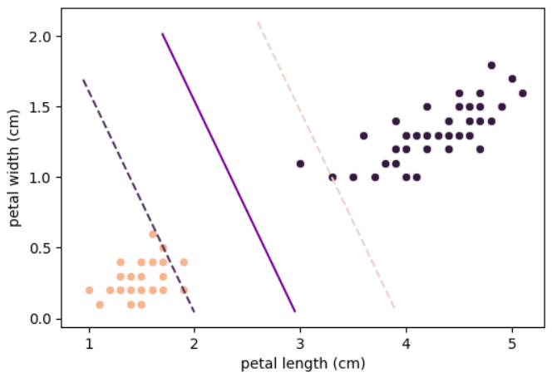
Corrected version of the first model, with 2 minor misclassifications (Decision Boundary is now equidistant from the support vectors).
Regression using SVM
SVMs, although generally used for classification can be used for both regression and classification. Support Vector Regression (SVR) is a machine learning algorithm used for regression analysis. It is different from traditional linear regression methods as it finds a hyperplane that best fits the data points in a continuous space, instead of fitting a line to the data points.
SVR in contrast to SVM tries to maximise the number of points in the street (margin), the width is controlled by a hyperparameter ε (epsilon).
Press enter or click to view image in full size
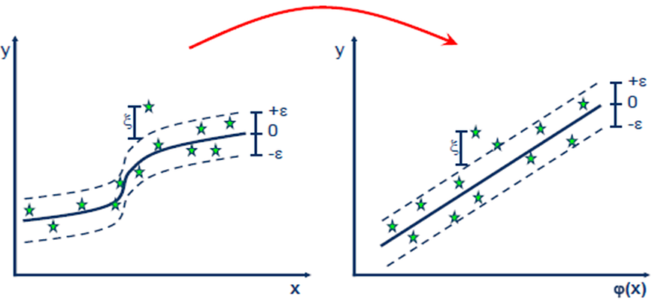
Support Vector Regression (SVR) the decision hyperplane is used to predict the value.
An analogy of this could be passing a flyover or a bridge over buildings or houses where we want to give shade to the most number of houses keeping the bridge thinnest.
SVR wants to include the whole data into its reach while trying to minimise the margin, basically trying to encompass the points. Whereas linear regression wants to pass a line such that the sum of distances of the points from the line is minimum.
The advantages of SVR over normal regression are:
- Non-linearity: SVR can capture non-linear relationships between input features and the target variable. It achieves this by using the kernel trick. In contrast, Linear Regression assumes a linear relationship between the input features and the target variable and Non-Linear Regression would require a lot of computation.
- Robustness to outliers: SVR is more robust to outliers compared to Linear Regression. SVR aims to minimize the errors within a certain margin around the predicted values, known as the epsilon-insensitive zone. This characteristic makes SVR less influenced by outliers that fall outside the margin, leading to more stable predictions.
- Sparsity of support vectors: SVR typically relies on a subset of training instances called support vectors to construct the regression model. These support vectors have the most significant impact on the model and represent the critical data points for determining the decision boundary. This sparsity property allows SVR to be more memory-efficient and computationally faster than Linear Regression, especially for large datasets. Also, an advantage is that after the addition of new training points the model does not change if they lie in the margin.
- Control over model complexity: SVR provides control over model complexity through hyperparameters such as the regularization parameter C and the kernel parameters. By adjusting these parameters, you can control the trade-off between model complexity and generalization ability this level of flexibility is not offered by linear regression.
Applications and Uses of SVM
Support Vector Machines (SVMs) have been successfully applied to various real-world problems across different domains. Here are some notable applications of SVMs:
- Image Classification: SVMs have been widely used for image object recognition, handwritten digit recognition and optical character recognition (OCR). They have been employed in systems like filtering image-based spam and face detection systems used for security, surveillance, and biometric identification.
- Text Classification: SVMs are effective for text categorization tasks, such as sentiment analysis, spam detection, and topic classification.
- Bioinformatics: SVMs have been applied in bioinformatics for tasks such as protein structure prediction, gene expression analysis, and DNA classification.
- Financial Forecasting: SVMs have been used in financial applications for tasks such as stock market prediction, credit scoring, and fraud detection.
- Medical Diagnosis: SVMs have been utilized in medical diagnosis and decision-making systems. They can assist in diagnosing diseases, predicting patient outcomes, or identifying abnormal patterns in medical images.
SVMs have also been applied in other domains such as geosciences, marketing, computer vision, and more, showcasing their versatility and effectiveness in various problem domains.

SVM – Advantage, Disadvantage & Applications (Climax Scene):
Advantage:
1. More effective for high dimensional space
2. Works well with even unstructured and semi-structured data like text, Images, and trees
3. Handles non-linear data efficiently by using the kernel trick
4. SVM has an L2 Regularization feature. So, it has good generalization capabilities which prevent it from over-fitting
5. A small change to the data does not greatly affect the hyperplane and hence the SVM. So the SVM model is stable
Disadvantage:
1. Not suitable for large dataset
2. Sensitive to outliers (If you have more in the dataset then SVM is not the right choice!)
3. Hyperparameters like cost (C) and gamma of SVM, is not that easy to fine-tune and also hard to visualize their impact
4. SVM takes a long training time on large datasets
5. SVM model is difficult to understand and interpret by human beings, unlike Decision Trees.
6. One must do feature scaling of variables before applying SVM
Applications:
1. Handwriting recognition
2. Face Detection
3. Text and hypertext categorization
4. Image Classification
5. Bioinformatics (protein classification and cancer classification)
While SVMs can be applied for a number of tasks, these are some of the most popular applications of SVMs across industries.
Text classification
SVMs are commonly used in natural language processing (NLP) for tasks such as sentiment analysis, spam detection, and topic modeling. They lend themselves to these data as they perform well with high-dimensional data.
Image classification
SVMs are applied in image classification tasks such as object detection and image retrieval. It can also be useful in security domains, classifying an image as one that has been tampered with.
Bioinformatics
SVMs are also used for protein classification, gene expression analysis, and disease diagnosis. SVMs are often applied in cancer research (link resides outside ibm.com) because they can detect subtle trends in complex datasets.
Geographic information system (GIS)
SVMs can analyze layered geophysical structures underground, filtering out the 'noise' from electromagnetic data. They have also helped to predict the seismic liquefaction potential of soil, which is relevant to field of civil engineering.

Linear SVMs
Linear SVMs are used with linearly separable data; this means that the data do not need to undergo any transformations to separate the data into different classes. The decision boundary and support vectors form the appearance of a street, and Professor Patrick Winston from MIT uses the analogy of "fitting the widest possible street"² (link resides outside ibm.com) to describe this quadratic optimization problem. Mathematically, this separating hyperplane can be represented as:
wx + b = 0
where w is the weight vector, x is the input vector, and b is the bias term.
There are two approaches to calculating the margin, or the maximum distance between classes, which are hard-margin classification and soft-margin classification. If we use a hard-margin SVMs, the data points will be perfectly separated outside of the support vectors, or "off the street" to continue with Professor Hinton’s analogy. This is represented with the formula,
(wx_{j} + b) y_{j} ≥ a,
and then the margin is maximized, which is represented as: max ɣ= a / ||w||, where a is the margin projected onto w.
Soft-margin classification is more flexible, allowing for some misclassification through the use of slack variables (`ξ`). The hyperparameter, C, adjusts the margin; a larger C value narrows the margin for minimal misclassification while a smaller C value widens it, allowing for more misclassified data³.
Nonlinear SVMs
Much of the data in real-world scenarios are not linearly separable, and that’s where nonlinear SVMs come into play. In order to make the data linearly separable, preprocessing methods are applied to the training data to transform it into a higher-dimensional feature space. That said, higher dimensional spaces can create more complexity by increasing the risk of overfitting the data and by becoming computationally taxing. The “kernel trick” helps to reduce some of that complexity, making the computation more efficient, and it does this by replacing dot product calculations with an equivalent kernel function⁴.
There are a number of different kernel types that can be applied to classify data. Some popular kernel functions include:
- Polynomial kernel
- Radial basis function kernel (also known as a Gaussian or RBF kernel)
- Sigmoid kernel
Support vector regression (SVR)
Support vector regression (SVR) is an extension of SVMs, which is applied to regression problems (i.e. the outcome is continuous). Similar to linear SVMs, SVR finds a hyperplane with the maximum margin between data points, and it is typically used for time series prediction.
SVR differs from linear regression in that you need to specify the relationship that you’re looking to understand between the independent and dependent variables. An understanding of the relationships between variables and their directions is valuable when using linear regression. This is unnecessary for SVRs as they determine these relationships on their own.

Important Points
- Maximizes the Margin:
SVM focuses on finding the decision boundary that maximizes the margin (the distance between the boundary and the closest data points of each class). This makes it more robust to new data.
- Handles Non-Linear Data:
SVM can handle non-linear data using the “kernel trick,” which transforms the data into a higher-dimensional space where it becomes easier to separate.
- Effective in High Dimensions:
SVM works well even when the number of features (dimensions) is much larger than the number of samples, making it suitable for complex datasets.
- Robust to Overfitting:
By focusing on the points closest to the boundary (support vectors), SVM is less likely to overfit, especially in smaller datasets.
- Requires Tuning:
SVM requires careful tuning of parameters (like the choice of kernel and regularization) to achieve optimal performance, which can be time-consuming.

to other model comparisons, SVMs are more computationally expensive to train and less prone to overfitting, but neural networks are considered more flexible and scalable.

Logistic Regression VS Support Vector Machine (SVM)
Logistic Regression
- Probabilistic Approach:
Logistic Regression predicts the probability that an input belongs to a specific class (e.g., 80% chance of being “spam”). It uses the sigmoid function to map inputs to probabilities between 0 and 1.
- Linear Decision Boundary:
It assumes the data can be separated by a straight line (or a hyperplane in higher dimensions). If the data isn’t linearly separable, Logistic Regression may struggle.
- Simple and Interpretable:
It’s easy to implement and interpret, making it a good starting point for classification problems. The coefficients of the model can also tell you how each feature influences the outcome.
- Works Well for Linearly Separable Data:
Logistic Regression performs well when the relationship between the input features and the output is linear.
- Efficient for Large Datasets:
It’s computationally efficient and scales well to large datasets, making it a popular choice for many real-world applications.

Hyperparameter tuning
Intuition behind SVM:
deep intuition behind Support Vector Machines (SVMs) step-by-step — not just the math, but the reasoning and what it really means. You’ll walk away with both theoretical clarity and a visual/mental model of how SVM thinks.

🧠 What is the Core Idea of SVM?
SVM is a supervised learning algorithm used for classification and sometimes regression.
🔥 Core Idea:
Find the best boundary (hyperplane) that separates two classes with the maximum margin.
This hyperplane is not just any boundary — it’s the one that stays as far away as possible from both classes. This is why SVM generalizes well.

🚧 Problem Setup
Let’s assume:
- You have two classes: 🟥 Red ("Yes") and 🟦 Blue ("No")
- Each data point has two features so it can be plotted in 2D space
Visual Goal
You want to draw a line (or more generally, a hyperplane) that divides the red and blue points.
But unlike other classifiers (like logistic regression), SVM doesn’t just care about correct separation. It wants maximum separation — that’s called the margin.

🎯 Step-by-Step Intuition
1. Separating the Classes
First, SVM checks:
Can I draw a straight line that separates the classes perfectly?
If yes → It becomes a hard-margin SVM
If not → Use soft-margin SVM with slack (explained later)
But let’s stay with the simpler case for now — perfectly separable data.

2. What is a Margin?
A margin is the distance between the separating hyperplane and the closest data point from either class.
SVM wants to maximize this margin to make the classifier robust. Why?
Because if new data is slightly noisy, a bigger margin makes misclassification less likely.

3. Who Decides the Margin?
This is where Support Vectors come in.
Support vectors are the few points closest to the decision boundary.
They are the most “at risk” of misclassification, so they are critical to the model.
Only these points matter in training; all other points are ignored once the margin is set.
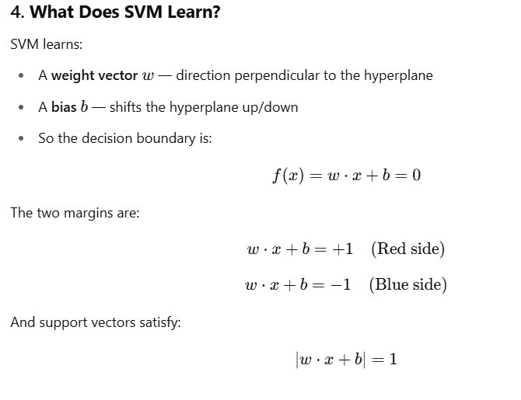
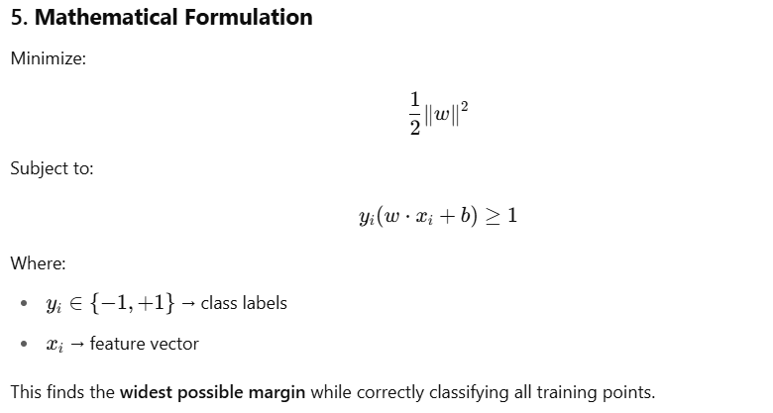
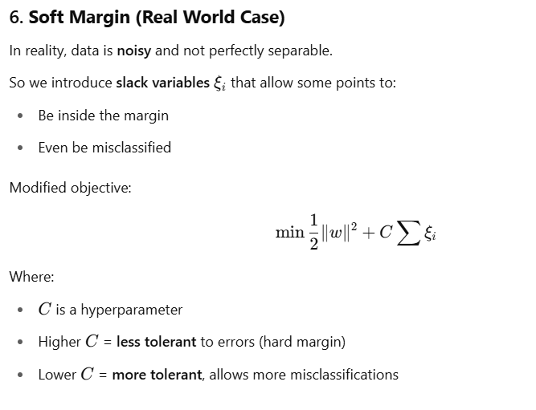

7. What About Nonlinear Data?
Sometimes the data can’t be separated with a straight line.
Example: Red dots in the middle, blue in a ring around it.
In that case, SVM uses a kernel function to project data into a higher-dimensional space, where it can be separated linearly.
Popular kernels:
Kernel | What It Does
Linear | No transformation, just a line
Polynomial | Adds polynomial features
RBF (Gaussian) | Maps data to infinite-dimensional space
Sigmoid | Similar to neural networks

8. Geometric Intuition Recap
SVM tries to:
- Place a line (or hyperplane) between two classes
- Maximize the distance from the line to the nearest point in each class
- Use only the points that touch the margin: the support vect
🤔 First Key Confusion: What Comes First?
❓Do we find support vectors first, or do we find the hyperplane first?
✅ Answer: Neither.
Both the hyperplane and the support vectors are found together, by solving an optimization problem.
Let’s explain what that means.

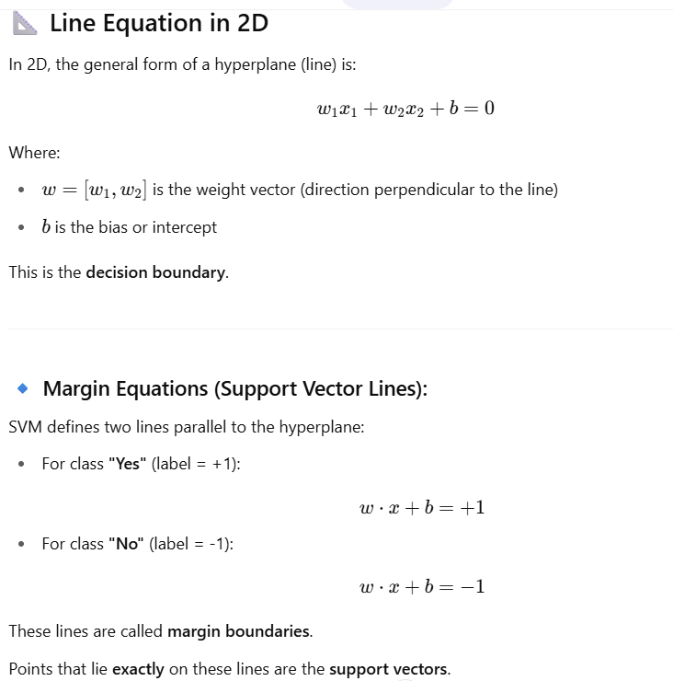

Now... How Does SVM Actually Find the Line?
Step-by-Step Intuition:
- Plot all the data: Red and blue points (no hyperplane yet).
- Now we want to find the best line that separates them.
But not just any line — we want the line that:
- Separates the two classes correctly
- Has the maximum possible distance (margin) to the closest red and closest blue points
This is formulated as a convex optimization problem:
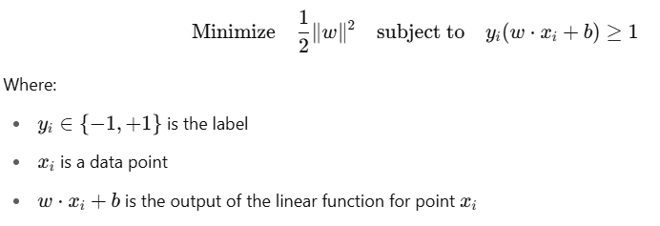
Key Insight: Support Vectors Are Found During Optimization
You are not required to know the support vectors before choosing the hyperplane.
Instead:
- You try to find a line that keeps all red points on one side and all blue on the other.
- While optimizing the margin, the algorithm automatically identifies the few closest points — these become the support vectors.
But… How does SVM know where the two classes are?
Great point.
Here’s how:
- You provide all the labeled data (i.e., "this point is Red", "that point is Blue").
- The optimization process knows which class each point belongs to (via yiy_iyi​).
- It tries to find a hyperplane such that red points satisfy w⋅x+b≥+1 and blue points satisfy w⋅x+b≤−1
- The algorithm checks both classes together and finds the narrowest band (maximum margin) that separates them.

Understanding the Optimization in SVM
Once you give the SVM algorithm your data points — with class labels (red = +1, blue = -1) — it tries to solve the following problem:
🎯 Objective:
Find the line (hyperplane) that separates the classes while maximizing the margin.

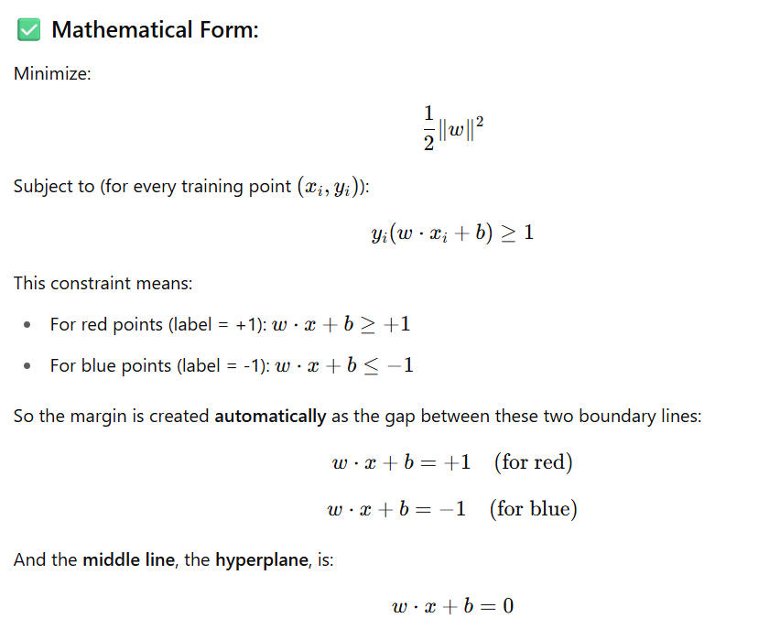

How Support Vectors Are Determined
While solving this optimization, the algorithm only looks at the points that are closest to the hyperplane — i.e., the points that lie exactly on:
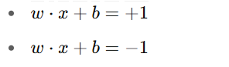
These closest points from each class are the support vectors. All other points don’t affect the placement of the hyperplane.
So:
- ✅ The SVM does not need to know support vectors beforehand.
- ✅ It discovers them while solving the optimization problem.
- ✅ Once found, the hyperplane is placed exactly halfway between the support vectors of both classes.

Visual Intuition
Let’s imagine a simple 2D plane.
Red points: top-right
Blue points: bottom-left

Red support vector: (2, 6)
Blue support vector: (4, 2)

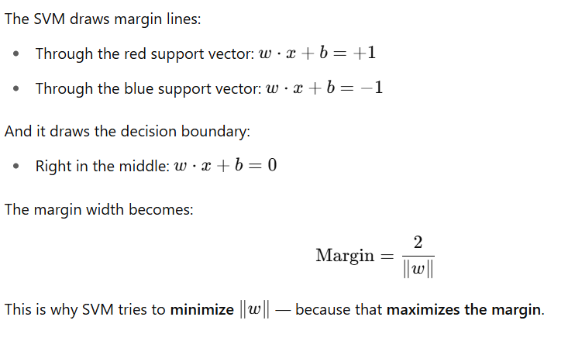

✅ You Asked: "What if I don’t know where the blue class lies?"
- When you only plot the red points, you cannot decide the hyperplane yet — you need both classes to compute the margin.
- Only after giving all data with class labels can SVM find:
  - Which red point is closest to the blue group
  - Which blue point is closest to the red group
  - Then, it places the decision boundary in between them
That’s why it’s not about drawing the line first — it’s about solving a mathematical problem to discover both the support vectors and the line together.
Constraints Optimization Problem in SVM (Soft Margin)
Hard Margin and Soft Margin SVM
Hard Margin and Soft Margin SVM with the red-blue point example, and understand how and why they differ — both theoretically and practically.

🔵🔴 Imagine a Binary Classification Problem
You have:
- Red points (Class 0) → 🔴
- Blue points (Class 1) → 🔵
- Each point has 2 features → can be plotted in 2D space

🎯 Goal of SVM
Find the "best separating hyperplane" that maximizes the margin between classes.

📌 First, Let’s Understand the "Hard Margin" SVM
🔒 Hard Margin SVM (Strict SVM)
🔍 Theoretical Conditions:
- Assumes data is perfectly linearly separable.
- No tolerance for misclassification.
- All points must lie outside the margin.
- No noise or overlap in the data.
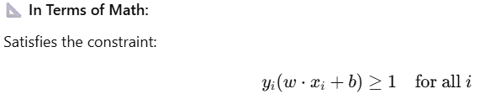

This means:
- Red points lie on one side of the hyperplane.
- Blue points lie on the other side.
- The margin is as wide as possible.
⚠️ When to Use:
- In rare cases where the dataset is clean, linearly separable, and noise-free.
- Synthetic or idealized datasets.
❌ Problem:
- Real-world data is noisy.
- Outliers and overlaps cause hard margin SVM to fail (no perfect separator).

🧵 Now Enter — Soft Margin SVM
🎯 Soft Margin SVM (Flexible SVM)
🔍 Theoretical Conditions:
- Allows some data points to:
  - Lie within the margin
  - Even be misclassified
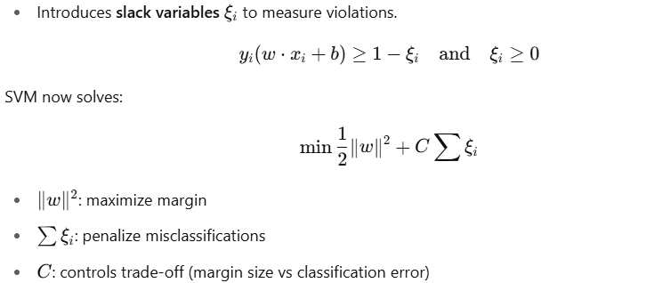

⚙️ Intuition:
SVM now balances two things:
- Keep the margin as wide as possible (like hard margin)
- But also allow some errors to not overfit
📦 When to Use:
- Real-world data
- Noisy or overlapping data
- Outliers are present
- Imperfect class separation

🔴🔵 Let’s Use the Red-Blue Example
✅ In a Hard Margin World:
If your red 🔴 and blue 🔵 points are nicely clustered apart with no mixing:
- SVM draws a clear line between the two.
- All points lie outside the margin.
- A wide margin is possible.
- Support vectors touch the margin boundaries exactly.
❌ But If You Introduce Noise:
Let’s say a couple of blue 🔵 points end up in the red 🔴 cluster:
- Hard Margin SVM will fail — it won’t be able to separate them without misclassifying.
- It may find no solution.
✅ Soft Margin SVM Saves the Day:
- It allows the few “wrong” blue points to be within or even on the wrong side of the boundary.
- It doesn’t let these points dictate the entire decision boundary.
- The bulk of data still guides the margin.

🧠 What Is SVM Optimizing, Conceptually?
Margin Type | SVM Is Trying To... | Misclassifications? | Data Type
Hard Margin | Find widest margin with 100% accuracy | ❌ Not allowed | Clean, separable
Soft Margin | Find widest possible margin, even with few errors | ✅ Allowed (controlled by C) | Real-world, noisy

🔧 C Hyperparameter in Soft Margin SVM
- Large CCC = Try to minimize errors → behaves like hard margin → smaller margin
- Small CCC = Allow more slack/errors → wider margin → better generalization
Think of it as:
🧱 "How hard should SVM try to classify training data perfectly?"

✅ Summary
Feature | Hard Margin SVM | Soft Margin SVM
Assumes perfect separation | ✅ Yes | ❌ No
Allows margin violations | ❌ No | ✅ Yes (using slack ξ (xi))
Handles noise & outliers | ❌ Poorly | ✅ Robustly
Use case | Clean, synthetic data | Noisy, real-world data
Controlled by | Margin only | Margin + penalty C

Kernal transformation:

Why Do We Need Kernel Transformation?
🔴🔵 Suppose:
You’re trying to separate red 🔴 and blue 🔵 data points.
In many real-world cases, data is not linearly separable in its original form. That means you cannot draw a straight line (or hyperplane) to separate classes perfectly.
Example:
A circular boundary — where red points are surrounded by blue points — a line just won’t work.
So what can we do?
🎯 We transform the data into a higher-dimensional space where it becomes linearly separable.
This is the idea behind Kernel Transformation.
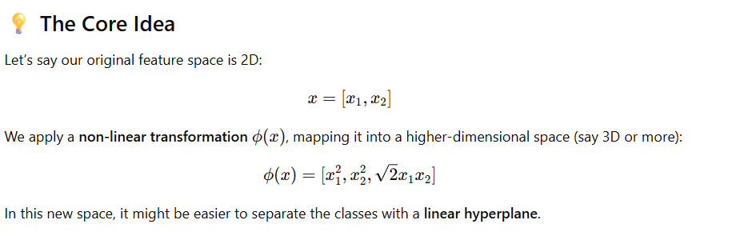
But Wait — Isn’t That Computationally Expensive?
Yes! Calculating ϕ(x) for all training examples in a very high-dimensional space would be costly.
That’s where the Kernel Trick comes in.

🧙‍♂️ The Kernel Trick
Instead of explicitly computing ϕ(x) (phi), we compute:
K(x,x′)=ϕ(x)⋅ϕ(x′)
That is, the dot product of the transformed vectors, without ever computing the transformation itself.
✅ Efficient
✅ Implicit high-dimensional mapping
This function K(x,x′) is called a kernel function.

🧰 Commonly Used Kernels
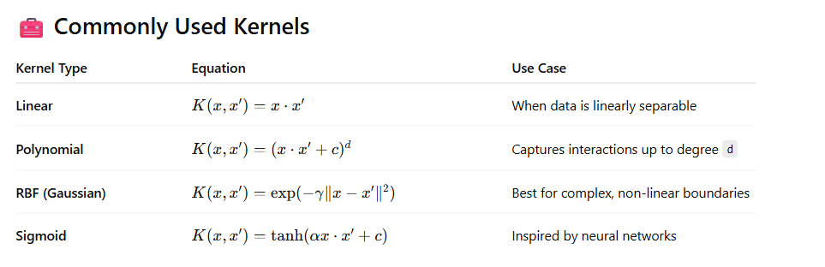

🧪 Example: RBF Kernel Intuition
Suppose we have data like this:
- Blue 🔵 points are in the center.
- Red 🔴 points form a ring around them.
This is not separable by a straight line, but if we project the data into a higher-dimensional space where:
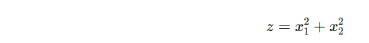
Now, it becomes separable with a plane in the z-direction.
RBF kernel does this transformation implicitly.

🧠 Summary of Kernel Transformation
Concept | Meaning
Feature Mapping ϕ(x) | Map low-dimensional data to high-dimensional space
Kernel Trick | Compute dot product in high-dimensional space without explicit transformation
Kernel Function | Measures similarity between inputs xxx and x′x'x′
Why Use | Enables SVM to solve non-linear problems efficiently

1. Linear Kernel
📌 Formula:
K(x,x′)=x⋅x′
🧠 Intuition:
- No transformation is applied.
- Equivalent to the standard dot product.
- Works in the original input space.
📈 When to Use:
- When data is linearly separable or almost linear.
- Good for high-dimensional, sparse data, e.g.:
  - Text classification (bag-of-words, TF-IDF)
  - Gene expression data
⚡ Fast and Simple:
- Least computational cost
- No extra hyperparameters

🧮 2. Polynomial Kernel
📌 Formula:
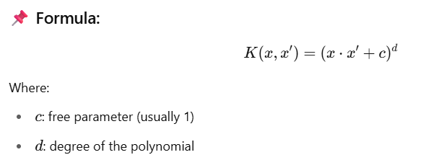
🧠 Intuition:
- Captures interactions between features.
- Degree d controls the complexity of the model.
  - d=2d = 2d=2: includes squares and cross-products
  - d=3d = 3d=3: cubes, triple-feature interactions, etc.
📈 When to Use:
- When data is not linearly separable but still has some structured curvature.
- Useful when you want to model feature interactions explicitly.
⚠️ Drawbacks:
- Can be computationally expensive with large d
- May overfit with high-degree polynomials

🌀 3. RBF (Radial Basis Function) / Gaussian Kernel
📌 Formula:
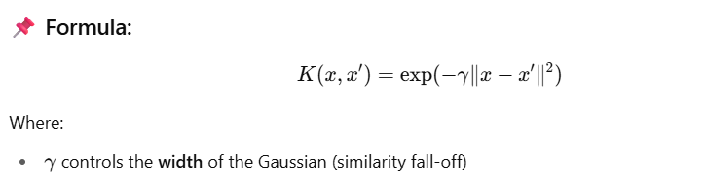
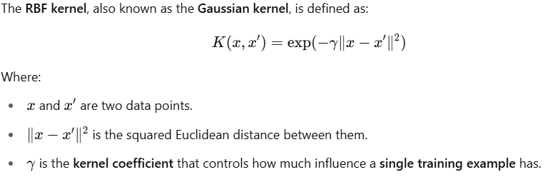
Where:
- γ gamma controls the width of the Gaussian (similarity fall-off)

🎯 What is gamma?
✅ It controls the shape and smoothness of the decision boundary.
- A small gamma → far influence: each data point affects a large region.
- A large gamma → close influence: each data point affects only nearby points.

📌 Intuition
🔵 Small gamma (e.g., 0.1 or 0.01):
- Points are seen as globally similar.
- Decision boundary is smoother and more generalized.
- Risk: Underfitting (not flexible enough to capture patterns).
🔴 Large gamma (e.g., 10 or 100):
- Points are seen as only locally similar.
- Decision boundary is tightly fitted to training data.
- Risk: Overfitting (fits noise in the training data).

🧪 Visual Example
Imagine a data point is a "hill":
- Small gamma → a wide hill → affects more area
- Large gamma → a sharp narrow peak → affects only nearby space

📊 Real-world Analogy
Think of gamma as the sensitivity knob:
- Low sensitivity: sees broad differences (low gamma)
- High sensitivity: reacts sharply to small differences (high gamma)

⚙️ In scikit-learn
python
CopyEdit
from sklearn.svm import SVC

model = SVC(kernel='rbf', gamma=0.1)
You can also use 'scale' or 'auto':
- 'scale': default, sets gamma = 1 / (n_features * X.var())
- 'auto': sets gamma = 1 / n_features

🧠 Intuition:
- Compares distance between points.
- Points closer are more similar → higher kernel value.
- Points farther are almost zero → ignored.
📈 When to Use:
- When the decision boundary is highly non-linear.
- Best default choice when:
  - You have no idea about feature interactions
  - You suspect non-linearity but don’t know the form
🔧 Hyperparameter:
- gamma: higher = more sensitive (tight clusters)
- Can overfit if gamma too high, or underfit if too low
✅ Often a good first try!

🔌 4. Sigmoid Kernel
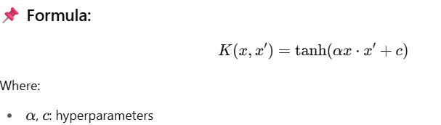
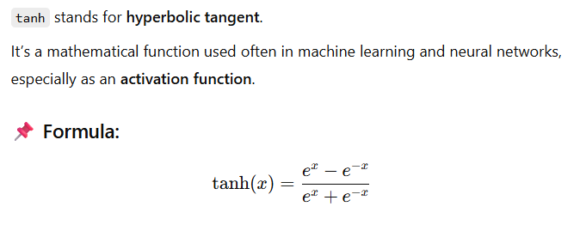
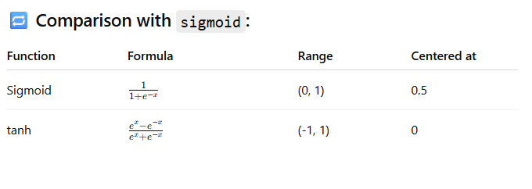
🧠 Intuition:
- Inspired by neural networks (activation functions).
- Non-linear transformation of dot product.
📈 When to Use:
- Rarely used.
- Historically used when trying to mimic neural networks with SVMs.
- May not satisfy Mercer’s condition (validity of kernel matrix) for all values.
⚠️ Caveats:
- Often outperformed by RBF in practice.
- Only useful in specific cases, such as experimentation.

🔢 Summary Table
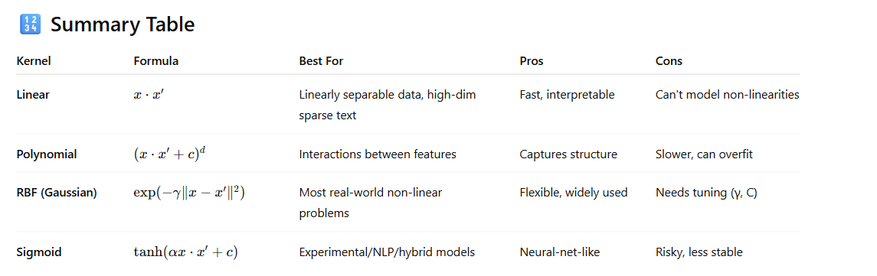

✅ Choosing the Right Kernel
Scenario | Recommended Kernel
Clean linear separation | Linear
Curved but structured boundary | Polynomial
Unknown shape / complex | RBF
Mimicking neural nets | Sigmoid (rarely)

1. Linear Data — linear kernel
🧠 Intuition:
- Data is linearly separable (can be separated by a straight line/hyperplane).
- SVM finds the best linear separator.
🔢 Code:
python
CopyEdit
from sklearn import datasets
from sklearn.svm import SVC
from sklearn.model_selection import train_test_split
import matplotlib.pyplot as plt
from mlxtend.plotting import plot_decision_regions

# Load linear data (only 2 features for plotting)
X, y = datasets.make_classification(n_samples=100, n_features=2,
n_redundant=0, n_informative=2,
n_clusters_per_class=1, random_state=1)

# Train SVM with linear kernel
model = SVC(kernel='linear', C=1)
model.fit(X, y)

# Plot decision boundary
plot_decision_regions(X, y, clf=model)
plt.title('SVM with Linear Kernel')
plt.show()

✅ 2. Nonlinear Data — rbf kernel
🧠 Intuition:
- Data can't be separated by a straight line.
- RBF (Radial Basis Function) kernel maps data into higher-dimensional space.
- SVM finds a linear separator in that space, which is non-linear in original space.
🔢 Code:
python
CopyEdit
from sklearn.datasets import make_circles

# Create nonlinear (circular) data
X, y = make_circles(n_samples=100, factor=0.3, noise=0.1)

# Train SVM with RBF kernel
model = SVC(kernel='rbf', C=1, gamma='auto')
model.fit(X, y)

# Plot decision boundary
plot_decision_regions(X, y, clf=model)
plt.title('SVM with RBF Kernel')
plt.show()

✅ 3. Polynomial Data — poly kernel
🧠 Intuition:
- Data follows a polynomial pattern (e.g., parabolas, curves).
- Polynomial kernel allows fitting such curves by considering higher-degree feature interactions.
🔢 Code:
python
CopyEdit
from sklearn.datasets import make_moons

# Create semi-linear but curved (moons) data
X, y = make_moons(n_samples=100, noise=0.1)

# Train SVM with Polynomial kernel
model = SVC(kernel='poly', degree=3, C=1)
model.fit(X, y)

# Plot decision boundary
plot_decision_regions(X, y, clf=model)
plt.title('SVM with Polynomial Kernel (degree=3)')
plt.show()

🎯 Summary Table
Data Type | Kernel Used | Use When...
Linear | 'linear' | Data is linearly separable
Nonlinear (e.g., circular) | 'rbf' | Data requires complex, radial boundaries
Polynomial (e.g., U-shape) | 'poly' | Data shows curved but structured boundaries

from sklearn.svm import SVC
import matplotlib.pyplot as plt
from sklearn.datasets import make_classification

# Create toy data
X, y = make_classification(n_samples=100, n_features=2, n_classes=2, n_clusters_per_class=1)

# Train SVM
clf = SVC(kernel='linear')
clf.fit(X, y)

# Plot
plt.scatter(X[:, 0], X[:, 1], c=y)
ax = plt.gca()
xlim = ax.get_xlim()

w = clf.coef_[0]
b = clf.intercept_[0]
x = np.linspace(xlim[0], xlim[1])
y = -(w[0] * x + b) / w[1] # decision boundary
plt.plot(x, y, 'k--')

# Margins
margin = 1 / np.linalg.norm(w)
y_margin_up = y + margin
y_margin_down = y - margin
plt.plot(x, y_margin_up, 'r--')
plt.plot(x, y_margin_down, 'b--')
plt.title("SVM with Margins")
plt.show()

import numpy as np
import matplotlib.pyplot as plt
from sklearn import datasets
from sklearn.svm import SVC

# Generate synthetic data (2D, binary classification)
X, y = datasets.make_blobs(n_samples=100, centers=2, random_state=6, cluster_std=1.5)

# Train a linear SVM classifier
clf = SVC(kernel='linear', C=1.0)
clf.fit(X, y)

# Get the separating hyperplane parameters
w = clf.coef_[0]
b = clf.intercept_[0]

# Create a grid to plot the decision boundary
x_min, x_max = X[:, 0].min() - 1, X[:, 0].max() + 1
y_min, y_max = X[:, 1].min() - 1, X[:, 1].max() + 1
xx = np.linspace(x_min, x_max, 100)
yy = -(w[0] * xx + b) / w[1] # Decision boundary
margin = 1 / np.sqrt(np.sum(clf.coef_ ** 2))
yy_down = yy - np.sqrt(1 + (w[0]/w[1])**2) * margin
yy_up = yy + np.sqrt(1 + (w[0]/w[1])**2) * margin

# Plot
plt.figure(figsize=(10, 6))
plt.scatter(X[:, 0], X[:, 1], c=y, cmap=plt.cm.coolwarm, s=30)
plt.plot(xx, yy, 'k-', label='Decision boundary (w·x + b = 0)')
plt.plot(xx, yy_down, 'k--', label='Margin (w·x + b = -1)')
plt.plot(xx, yy_up, 'k--', label='Margin (w·x + b = +1)')
plt.scatter(clf.support_vectors_[:, 0], clf.support_vectors_[:, 1],
s=150, facecolors='none', edgecolors='k', label='Support Vectors')
plt.legend()
plt.title('SVM Decision Boundary with Margins and Support Vectors')
plt.xlabel('Feature 1')
plt.ylabel('Feature 2')
plt.grid(True)
plt.show()

Benefits of Using SVM in Different Contexts
SVM (Support Vector Machine) is a powerful and flexible algorithm. Here are key benefits when dealing with different types of data and problems:

🔹 1. Handling Outliers (Robustness to Noise)
- How SVM helps:
  - SVM is based on support vectors, not all data points.
  - Outliers far away from the margin don’t affect the decision boundary much (especially with soft margin SVM).
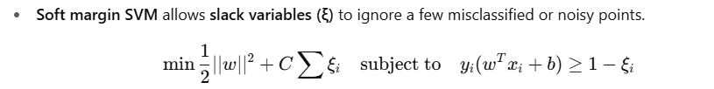

🔹 2. Non-Linear Data Handling
- How SVM helps:
  - Uses kernel functions (like RBF, polynomial) to project data into higher dimensions where it becomes linearly separable.
  - No need to manually add complex features — kernel trick handles it efficiently.

🔹 3. Small and High-Dimensional Datasets
- How SVM helps:
  - Effective in high-dimensional spaces (e.g., text classification).
  - Works well when number of features > number of samples.

🔹 4. Clear Margin of Separation
- SVM explicitly maximizes the margin (distance between the hyperplane and nearest points), improving generalization.

🔹 5. Binary Classification
- SVM excels in binary classification problems with clear class separation.
- For multi-class tasks, one-vs-one or one-vs-rest strategies are used.

🔹 6. Well-Formulated Optimization Problem
- SVM uses a convex optimization problem:
  - Guarantees a unique, global minimum.
  - No local minima issues like neural networks.

📌 Summary Table
Scenario | How SVM Helps
Outliers / Noisy Data | Soft margin allows tolerance (controlled by C)
Non-linear Data | Kernel trick projects to higher dimension
High-dimensional Data | Still performs well; only uses support vectors
Small Datasets | Avoids overfitting through margin maximization
Clear Class Boundaries | Margin-based optimization finds best separator
Optimization Formulation | Convex problem → unique, stable solution

